# Operational Concept Description (OCD)

**Fōkcus**

**Team 08**

|  |  |  |  |  |  |  |  |  |  |  |  |  |  |  |  |  |
| --- | --- | --- | --- | --- | --- | --- | --- | --- | --- | --- | --- | --- | --- | --- | --- | --- |
| |  |  | | --- | --- | | **Namee** | **Roleole** | | Steven Holland | Requirement Engineer, Project Manager | | Arik Oganesian | Operation Concept Engineer, Software Architect | | Marco Alvarez | Feasibility Architect, Software Architect | | Pin-Chih (Bill) Lin | Prototyper, Software Architect | | Tatsuhiko (Tats) Tomita | Lifecycle Planner, Software Architect | | Hamed Sadeghi | Prototyper | | Dennis Xiang | IIV&V, Quality Focal | |

**04/28/2017**

# Version History

| Date | Author | Version | Changes made | Rationale |
| --- | --- | --- | --- | --- |
| 10/10/16 | Sadeghi | 1.0 | * Created the First Draft | * Initial draft for use in ARB presentation |
| 10/17/16 | Sadeghi | 2.0 | * First ARB Version | * Applied the received comments and suggestions during the ARB presentation |
| 11/30/16 | Sadeghi | 3.0 | * ER Diagram Updated | * Initial draft for use in second ARB presentation |
| 12/04/16 | Sadeghi | 4.0 | * Benefit Chain Diagram updated /Descriptions updated/ Spelling errors corrected | * End of the Fall Semester |
| 02/10/17 | Sadeghi | 5.0 | * ER Diagram Updated. * System Boundaries Updated | * RDCR ARB |
| 4/28/2017 | MA | 5.1 | * Changed some diagrams (systems diagram and ED) | * As Built Packet |

# Table of Contents

Operational Concept Description (OCD) i

Version History ii

Table of Contents ii

Table of Tables iv

Table of Figures v

1. Introduction 1

1.1 Purpose of the OCD 1

1.2 Status of the OCD 1

2. Shared Vision 2

2.1 Benefits Chain 3

2.2 System Capability Description 4

2.3 System Boundary and Environment 4

3. System Transformation 6

3.1 Information on Current System 6

3.2 System Objectives, Constraints and Priorities 6

3.3 Proposed New Operational Concept 8

# Table of Tables

Table 1: The Program Model 2

Table 2: Level of Service Goals 7

Table 3: Relation to Current System 8

# Table of Figures

Figure 1: Benefits Chain Diagram 3

Figure 2: System Boundary and Environment Diagram 5

Figure 3: Element Relationship Diagram 9

### Introduction

#### Purpose of the OCD

The visions and goals of project “Focus” is defined in this document. The stakeholders in this project include the team 08 members as developers, Kurling Robinson as the client and future entrepreneurs and mentors as users.

#### Status of the OCD

This is the 5th version of this document, and Hamed Sadeghi is assigned to have the initial draft ready by 02/10/17 to put on our website.

### Shared Vision

Most people get educated on a single topic and regardless of how good they are at it, implementing it and making an idea practical requires variety of skills. Those who envision starting a company or start-up need mentorship and our client has access to thousands of mentors who already provide mentorship for those who seek it. Our application will facilitate this relation and will provide this service for entrepreneurs across the US where ever there is internet and will help those mentors to mentor more mentees. Plus, we hope to built a community for like minded people to share their experience and seek help.

The Program Model is shown in the table below:

Table : The Program Model

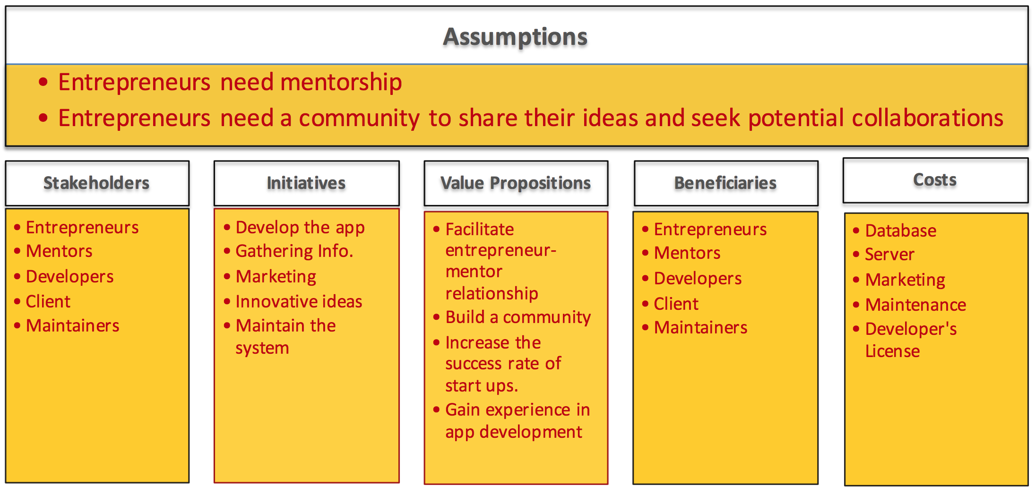

#### Benefits Chain

Below is our Benefit Chain Diagram:

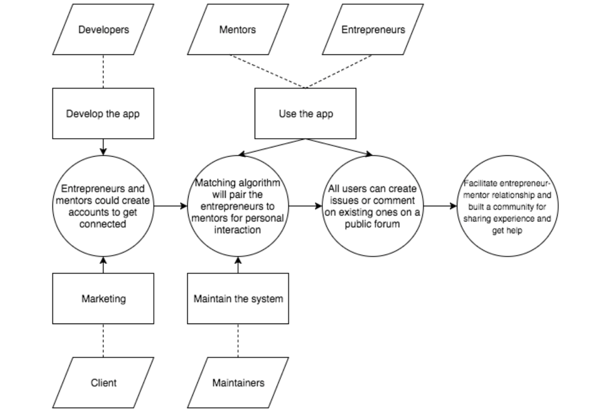

Figure : Benefits Chain Diagram

#### System Capability Description

Focus is an iOS application to match entrepreneurs to appropriate mentors and provide an access to a large community of like minded people to seek help and share their experience:

* The type of system to be built: iOS app
* The target customer(s) for the system: Entrepreneurs in tech industry
* The need or opportunity that will be satisfied by the system: Matching to appropriate mentors
* A compelling reason for the customer to buy/use the system: Easy, time saving and very beneficial.
* The closest competitor of the system: LinkedIn
* The system's primary differentiation from, or benefit over, the closest competitor or alternative approach, if there are competitors or alternatives ah the time: We have access to a pool of thousands mentors specialized in variety of fields

#### System Boundary and Environment

The system boundary and environment diagram contains a list of services and functions that the project team will be responsible for developing and delivering, as well as the system environment showing the stakeholders' organizations and other systems for which the project has no authority or responsibility, but with which the delivered system must interface in order to deliver the desired benefits.

The figure below shows is the system boundary diagram of the “Focus” app.

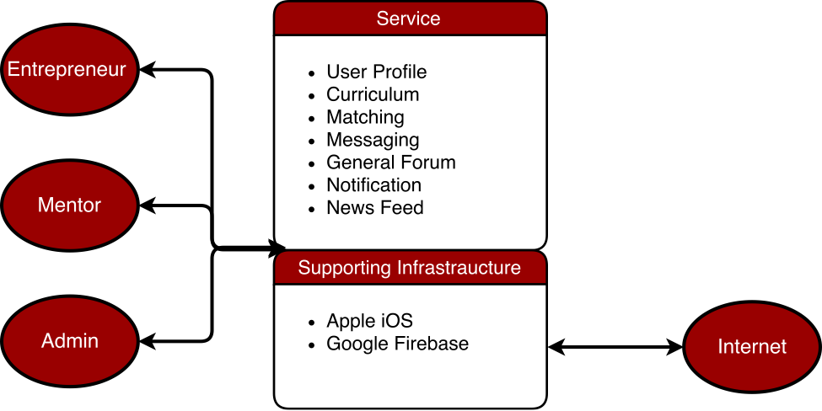

Figure : System Boundary and Environment Diagram

### System Transformation

#### Information on Current System

##### Infrastructure

There is no current system. Our client provides in person mentorship to people who seek it.

##### Artifacts

No current artifacts.

##### Current Business Workflow

Currently there is no business workflow.

#### System Objectives, Constraints and Priorities

##### Capability Goals

|  |  |
| --- | --- |
| **Capability Goals** | **Priority Level** |
| OC-1: Communication Channel: The system is capable of providing communication between users. | Medium |
| OC-2: Account: The system is capable of providing customized user profile. | High |
| OC-3: Matching Algorithm: The system is capable of providing a matching algorithm for mentors and mentees. | High |
| OC-4: Customized User Profile: The system is capable of providing a customized user profile. | Medium |

##### Level of Service Goals

Table : Level of Service Goals

|  |  |  |
| --- | --- | --- |
| **Level of Service Goals** | **Priority Level** | **Referred WinWin Agreements** |
| Communication Channel | High | WC_4146 |
| Communication Channel | High | WC_4142 |
| Communication Channel | High | WC_4083 |
| Account | Medium | WC_4010 |
| Account | Medium | WC_4003 |
| Account | Medium | WC_4001 |
| Account | Medium | WC_3993 |
| Customized User Profile | Medium | WC_4081 |
| Customized User Profile | Medium | WC_4080 |
| Matching Algorithm | High | WC_4018 |
| Matching Algorithm | High | WC_4011 |
| Matching Algorithm | high | WC_4094 |

##### Organizational Goals

**OG-1:** Facilitate entrepreneur-mentor relationship

**OG-2:** Build a community

**OG-3:** Increase the success rate of start ups.

**OG-4:** Gain experience in app development

##### Constraints

**CO-1:** **iOS Operating System**: Users must use iOS platform.

**CO-2: Team Members leaving:** We will lose half of our team at the end of this semester.

**CO-3: Costs**: As users grow the maintenance cost for the web server and the database service will increase.

##### Relation to Current System

There is no current platform for our app and we start from the scratch. Although the service is provided by our client for those who seek it based on in person interaction.

Table : Relation to Current System

|  |  |  |
| --- | --- | --- |
| **Capabilities** | **Current System** | **New System** |
| Roles and Responsibilities | No current system | New roles |
| User Interactions | In-person | online |
| Infrastructure | N.A. | iOS app |
| Stakeholder Essentials and Amenities | Only mentor and mentee | Developer, Maintainer |
| Future Capabilities | N.A. | Large community of entrepreneurs and mentors to interact and seek help |

#### Proposed New Operational Concept

This section contains information about the transformation of new operational concept that will be introduced to the system.

##### Element Relationship Diagram

The element relationship diagram summarizes the major relationships among the primary elements and external entities involved in the proposed new system. The entities include actors or users as well as external systems and components that interface with the system. The dashed box represents our proposed system, the boxes outside the dashed box represent external element that our system has to communicate with.

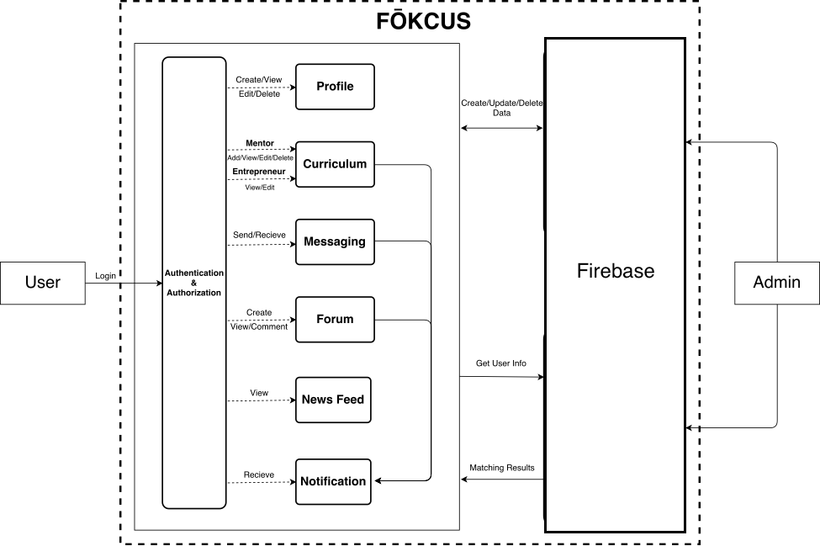

Figure 3: Element Relationship Diagram